


Committee on Committees Minutes

Associated Students
DATE: May 13, 2026
LOCATION: AS Main CoC Room Minutes/Actions recorded by: Vice Chair

CALL TO ORDER: 5:00PM by Lily, Internal Chair

QOTW: What is one item you have to have in your bag/backpack while on campus?

A. MEETING BUSINESS

- Roll Call

Name | Note:  absent (excused/not excused)  arrived late (time)  departed early (time)  proxy (full name) | Name | Note:  absent (excused/not excused)  arrived late (time)  departed early (time)  proxy (full name)
Lily Strange | Present | Savanah Lizet Aldaba | Present
Shuyi Sum | Present | Adam Orenstein | ...
Oliver Ramirez Carrera | Present | Archish Prakhya | Present
Layla Hakim | Present
Mira Ikladious | Present

- Acceptance of Excused Absences

MOTION/SECOND: Last Name/Last Name
Motion Language: SAMPLE MOTION LANGUAGE
ACTION: Consent

- Acceptance of Proxies

B. PUBLIC FORUM

- EXTERNAL REPORTS

Advisor’s Report

Executive Officer’s Report(s)

Group Project/Member Report(s)
  - Advisor and Senate Liaison Reports

Lily Strange - Internal Chair
    - QOTW: CHAPSTICK and my charger
    - Filled out the honoraria form for everyone! Hopefully we should be getting those soon.
    - State of the Association this next Tuesday 5:30-8pm (usually wraps up around 7) free dinner. I’ll be there, RSVP if you wish
      - RSVP
    - Who is available to help update the website? We have a some more AS orgs to add:
      - Office of the Controller
      - IVCRC
      - Coastal fund and Bike Committee (??? didn't attach forms, we need to find them)
        - Can we get an email out to all chairs currently with positions opened (all on the spreadsheet that are not green minus these we need to add) if they are still open
    - 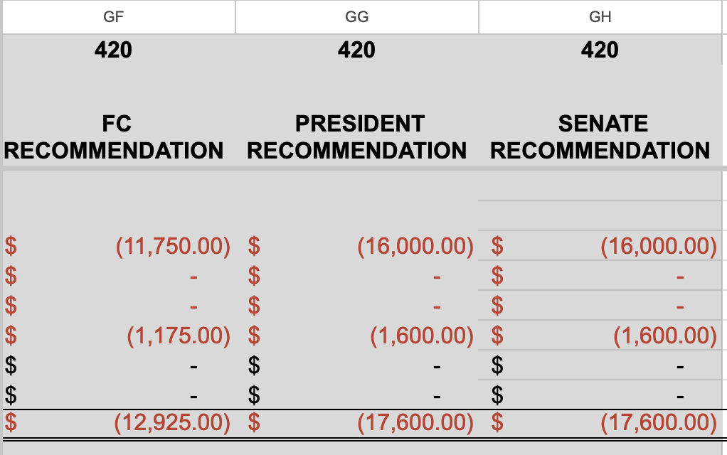Budget update!
      - We got much more budget for next year
      - I did not request rollover this year, so let’s please do our best to spend the remaining (~600 ish, will recalculate with less honoraria for spring)
    - A reminder that completed pass down reports were due this meeting
      - I forgot to send a reminder about this, so if you need to submit by tomorrow that’s totally fine
      - Here is the template again
    - Event tm !!!! THANK YOU MIRAAA
    - Yerbs week 10 power up your resume

Shuyi Sum - External Chair
    - QOTW: laptop charger and chewing gum
    - Interviewed Becky w/ Layla and Savanah, see Becky O&R Careers Coordinator Interview
    - Set up two other interviews this week
    - Need to deliberate Thomas, Becky, Kristin
    - State of the Association
      - I have work until 7pm, could make it to the later half if needed
    - Finished transition docs
      - External Chair Overview of Duties
      - Vice Chair Overview of Duties
    - Tasks:
      - Send acceptance email to Thomas for Internal Chair
      - Send acceptance email to Kristin for Internal Liaison
      - Send rejection email to Becky for O&R Careers Coordinator

Oliver Ramirez Carrera - Vice Chair
    - QOTW: My laptop!
    - Interviewed Thomas w/ Shuyi and Savanah
    - Interviewed Kristin w/ Layla and Savanah
    - In contact with Leah in regards to publishing the CoC website on its own bulk mail request
    - Been updating BCUs positions on the CoC website; looking at their Instagram to see if they’re hiring
    - CEC duties finally over
    - Tasks:
      - Need to do template, will finish by tonight!
      - Coastal fund and Bike Committee (??? didn't attach forms, we need to find them)
        - Can we get an email out to all chairs currently with positions opened (all on the spreadsheet that are not green minus these we need to add) if they are still open
      - Send out email regarding interview tomorrow
      - Text Yoyo about making a design for CoC

VACANT - Internal Liaison

Layla Hakim - Outreach and Recruitment Careers Coordinator
    - QOTW: aquafor
    - Interviewed Kristin with Savanah and Oliver
    - Interviewed Becky with Shuyi and Savanah
    - Made fliers for tomorrow’s event, sadly I can’t make it but hopefully the fliers are good
      - They’re based on our website, so idk how updated it is but hopefully its accurate
      - Added to the drive!

Mira Ikladious - Outreach and Recruitment Media Coordinator
i. QOTW: lipgloss + earbuds
ii. Interviewing a candidate tomorrow
iii. Finalized microix for the fuel your future event tmrw
^ Bryan just paid with T&E
iv. I still need to do pass down report !! → will do tmrw-ish
vii. Posted a couple times for event, posted on pardall ig as well
- Will print fliers for tmrw + PRINT SIGN UP SHEET FOR TMRW

VACANT - Outreach and Recruitment DEI Coordinator

Savanah Lizet Aldaba - Outreach and Recruitment On-Campus Coordinator
    - QOTW- My water bottle
    - Helped with interviewing Thomas, Becky, and Kristin
    - I submitted my requisition through Microix
    - Interviewing Charlie tomorrow at 1:00 pm.

Archish Prakhya - Pearman
QOTW - Airpods
Focusing on creating a poster project by May 18th
Open to attending or helping out with any interviews
Going to fill out Honoraria form

Adam Orenstein - Commissioner of Community and Climate

C. Action Items

- ACCEPTANCE of AGENDA/CHANGES to AGENDA

Motion to go into closed session to discuss COC applicants.

Motion to go out of closed session.

- CONSENT ITEMS

- Approval of our Action Summary/Minutes from:

- ACTION ITEMS

F-1. Old Business:

F-2 New Business:

- DISCUSSION ITEMS

- Discussion Topic
  - Sending acceptance emails to Thomas and Kristin
  - Rejecting Becky

- REMARKS

- ADJOURNMENT

MOTION/SECOND: Oliver/Lily
Motion Language: Motion to adjourn meeting at 5:45PM
ACTION: Consent

